Stock Track Investment Report
Student’s Name
Institution Affiliation

Overall Investments Need
When I started trading the ETF,s and stocks in the Stock Track Platform, I was expecting to be a profitable trader. I achieved this through back testing various trading strategy in the Demo portfolio until I was able to choose the best trading strategy. My main objective as a trader was to make at least 8% of profits in my portfolio investment on monthly with a goal of doubling my initial investment portfolio at the end of the year. This meant on annually basis I had to achieve a 100% profits in terms of my original portfolio investment. My risk tolerance was based on taking trades that had Risk Reward Ratio of 2:1 and above. This was working for me because to achieve my objectives I had to make sure that atleast out of ten trades I win four trades for me to be profitable.
Original Stock Track Portfolio Strategy
This process of trading ETF,s and stocks involves the use of chart patterns in trading breakouts and pullbacks in trending markets or ranging markets with simple moving average indicator, exponential moving average indicator, and RSI indicator.
First, perform top-down analysis, which involves drawing trend lines in the weekly chart, daily chart, 4hr chart, and 1 hr chart to establish if the market is trending upwards, trending downwards, or trending sideways. Secondly, draw the key support and resistance that might influence the trend patterns. After drawing your trendlines in up trending market or down trading markets which involves connecting higher highs and higher lows in the up-trending market, and connecting lower highs and lower lows in down trending markets, wait for the price to break out from the trendlines and form a pullback, retesting the trendline that the price has broken out from the uptrend or downtrend market, and enter the market after the crossover of Simple moving average set to the period of 8 and Exponential moving average set to the period of 21. Also, check for the RSI indicator and ensure its above 50 for un upward breakout and below 50 for a downtrend break out. Also consider divergences that gives great reversal signals. Your take profit should be set at the next support level or resistance level and use of 40 pips trailing stop loss. In terms of Risk Reward Ratio I always consider the portfolios that provide a risk reward ratio of 1:4 and set my Take profit 1 with a Risk Reward Ratio of 2:1. My entry in the market was through the use of buy stops and sell stops to the direction I anticipated the price would go. (Trend Analysis, 2015).
Stock Track Transaction Report
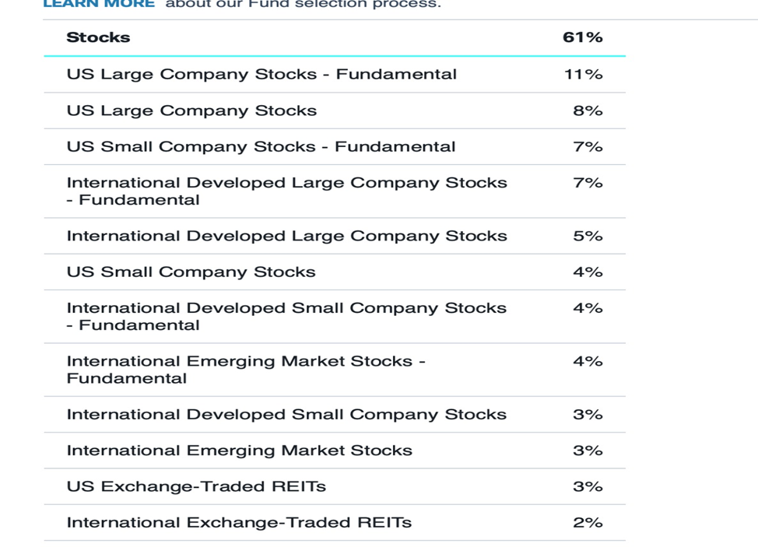
Figure 1
According to my trading portfolio figure 1 shows how I traded the ETF,s and Stocks in the stock track platform. In the stocks platform the biggest return in percentage is the Us large company stocks fundamentals with a return of 11% followed closely by the Us large stocks with a return of 8% and then the US small company stocks – Fundamental and the International developed large companies stocks with a return of 7% each. The above are the stocks that met my threshold of a return rate of an average of above 7%. Other stocks that provided an average percentage return include the International Developed small company stocks, US small company stocks, and International emerging market stocks – Fundamentals with an average return rate of 4% each. Other stocks were simply profitable in a small way include the International developed small company stocks- Fundamentals, International emerging market stocks and the US exchange traded REIT,s with an average profit percentage of 3%. In the last with the least percentage gain is the international exchange- traded REITs with a percentage return of 2%. On average monthly return rate was 5.08% and an annual return rate of 61%. This is a positive move towards achieving the monthly return rate of 8% and an annual return rate of 100% and above the amount of the investment portfolio I made. From Figure 1 we notice that the trading strategy was more effective on US large company stocks compared to others. This can be associated with good opportunities the US large company stocks offers with a high Risk Reward Ratio that is greater than the 3:1 risk reward ratio hence out of every 10trades I take am supposed to win at least 3 trades so as to be profitable.
Investment Portfolio Return compared to S&P 500 over the same time period has proven to be more profitable than trading the ETF,s and Stocks in Investment portfolio return for S&P 500 averages on 11% return rate per month compared to that of the stocks which has 5.08% returns on investment portfolio. The trading strategy has been successful in the S&P 500 compared to the stocks and ETFs thus the difference in return.
If I was to Invest in a mutual fund, I would invest in a passive fund that I will personally manage because I have surpassed the return rate of most of the Mutual fund that offer 20% return on investments. My investing strategies have proved to work currently with a return on investment of 61% that is comparatively higher when compared to that of many Mutual funds. I believe that my Investment strategies when incorporated in a robo-adviser can lead to maximum return on investment portfolio.

References
Trend Analysis: Improving the Probabilities. (2015). Profitable Candlestick Trading, 319–331. doi: 10.1002/9781119200888.ch14

